# MY THESIS TITLE

By

STUDENT NAME

Student ID: 12344567

A thesis Submitted to the

Department of Naval Architecture and Marine Engineering, Bangladesh University of Engineering and Technology,

In partial fulfillment of the requirements For the degree of

# MASTER OF SCIENCE

In

Naval Architecture and Marine Engineering



October 2024

Department of Naval Architecture and Marine Engineering, Bangladesh University of Engineering and Technology, Dhaka-1000, Bangladesh

# CERTIFICATE OF APPROVAL

The thesis titled “TITLE HERE,” submitted by Student name, Student No. 1234567, Session: October 2022, has been accepted as satisfactory in partial fulfillment of the requirement for the degree of Master of Science in Naval Architecture and Marine Engineering on October 2024.

Dr. Supervisor name Designation

## BOARD OF EXAMINERS

**Chairman**

Dept of NAME, BUET, DHAKA

Dr. Head name Professor and Head

Dept of NAME, BUET, DHAKA

## Member

Dr. Member name Designation

Dept of NAME, BUET, DHAKA

## Member

Dr. Member name Designation

Dept of NAME, BUET, DHAKA

## Member

Dr. External member name Designation

Department and Institute name

**Member (External)**

# CANDIDATE’S DECLARATION

It is hereby declared that this thesis or any part of it has not been submitted elsewhere for the award of any degree or diploma.

Signature of the Candidate Name:

Student ID:

Date:

**DEDICATION**

This thesis is dedicated to .............

**ABSTRACT**

Input your abstract here.....

**ACKNOWLEDGEMENT**

Input your acknowledgement here.....

# TABLE OF CONTENTS

|  |  |
| --- | --- |
| **ABSTRACT’****ACKNOWLEDGEMENT**  **NOMENCLATURE AND ABBREVIATIONS**  **1 INTRODUCTION** | **iv v x**  **1** |
| 1.1 Background and Present State . . . . . . . . . . . . . . . . . . . . . . . . . . | 1 |
| 1.2 Motivation . . . . . . . . . . . . . . . . . . . . . . . . . . . . . . . . . . . . | 2 |
| 1.3 Objective of The Research . . . . . . . . . . . . . . . . . . . . . . . . . . . . | 2 |
| 1.4 Methodology . . . . . . . . . . . . . . . . . . . . . . . . . . . . . . . . . . . | 2 |
| 1.5 Organization of the Thesis . . . . . . . . . . . . . . . . . . . . . . . . . . . . | 2 |
| **2 CHAPTER 2 NAME** | **3** |
| 2.1 Section 1 . . . . . . . . . . . . . . . . . . . . . . . . . . . . . . . . . . . . . | 3 |
| 2.2 Section 2 . . . . . . . . . . . . . . . . . . . . . . . . . . . . . . . . . . . . . | 3 |
| 2.3 Section 3 . . . . . . . . . . . . . . . . . . . . . . . . . . . . . . . . . . . . . | 3 |
| 2.4 Section 4 . . . . . . . . . . . . . . . . . . . . . . . . . . . . . . . . . . . . . | 3 |
| 2.5 Section 5 . . . . . . . . . . . . . . . . . . . . . . . . . . . . . . . . . . . . . | 3 |
| **3 CHAPTER 3 NAME** | **4** |
| 3.1 Section 1 . . . . . . . . . . . . . . . . . . . . . . . . . . . . . . . . . . . . . | 4 |
| 3.2 Section 2 . . . . . . . . . . . . . . . . . . . . . . . . . . . . . . . . . . . . . | 4 |
| 3.3 Section 3 . . . . . . . . . . . . . . . . . . . . . . . . . . . . . . . . . . . . . | 4 |
| 3.4 Section 4 . . . . . . . . . . . . . . . . . . . . . . . . . . . . . . . . . . . . . | 4 |

3.5 Section 5 4

1. CHAPTER 4 NAME 5
   1. Section 1 5
   2. Section 2 5
   3. Section 3 5
   4. Section 4 5
   5. Section 5 5
2. CHAPTER 5 NAME 6
   1. Section 1 6
      1. sub section 1 6
      2. sub section 2 6
      3. sub section 3 6
   2. Section 2 6
   3. Section 3 6
   4. Section 4 7
   5. Section 5 7
3. RESULTS AND DISCUSSIONS 8
4. CONCLUSIONS AND FUTURE SCOPES 9

BIBLIOGRAPHY 10

APPENDIX 11

**LIST OF FIGURES**

1.1 *𝐶𝑑* vs Re 1

1.2 Flow around a circular cylinder 2

**LIST OF TABLES**

1.1 Drag coefficients at different Reynolds numbers 2

# NOMENCLATURE AND ABBREVIATIONS

𝐶𝑑 Drag Coefficient

𝐶𝑙 Lift Coefficient

𝑅𝑒 Reynolds Number

# Chapter 1 INTRODUCTION

## Background and Present State

Insert text here. This is reference to a paper Ali and Bogna´r (2024). Two or more papers can be cited as (Ali and Bogna´r, 2024; Mohammadpour et al., 2024). You can insert equation. One example is

*𝐶𝑑* =

2*𝐹𝑑* (1.1)

*𝜌𝑈*2 *𝐴*

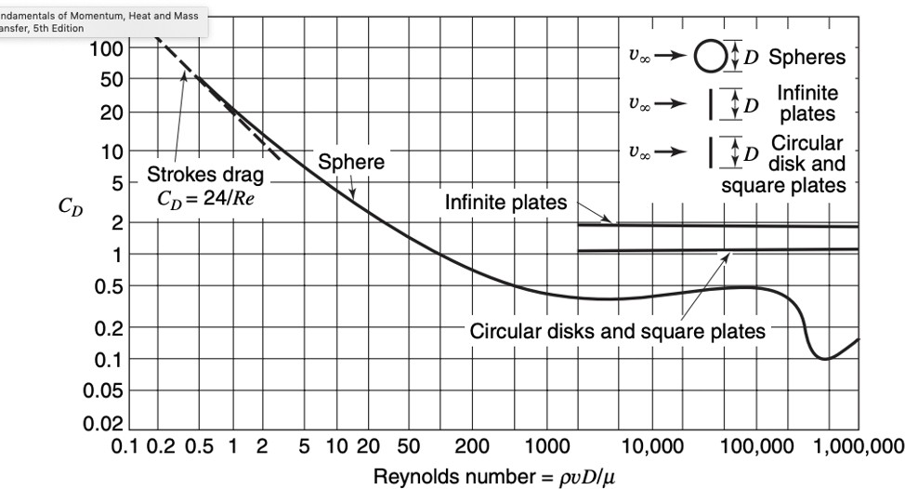

Figure 1.1: *𝐶𝑑* vs Re

## Motivation

The drag coefficient *𝐶𝑑* and Reynolds number *𝑅𝑒* are essential in fluid dynamics.

## Objective of The Research

Insert Text Here.

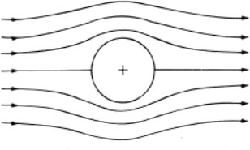

Figure 1.2: Flow around a circular cylinder

This way, a figure can be placed conveniently to conform to the requirements.

## Methodology

Insert Text Here

|  |  |
| --- | --- |
| Re | *𝐶𝑑* |
| *𝑅𝑒*1 | *𝐶𝑑*1 |
| *𝑅𝑒*2 | *𝐶𝑑*2 |

Table 1.1: Drag coefficients at different Reynolds numbers

## Organization of the Thesis

Insert Text Here

**Chapter 2**

# CHAPTER 2 NAME

## Section 1

Insert Text Here. The number and name of the sections can vary according to your thesis. Let’s add two figures side by side.

## Section 2

Insert Text Here

## Section 3

Insert Text Here

## Section 4

Insert Text Here

## Section 5

Insert Text Here

**Chapter 3**

# CHAPTER 3 NAME

## Section 1

Insert Text Here. The number and name of the sections can vary according to your thesis.

## Section 2

Insert Text Here

## Section 3

Insert Text Here

## Section 4

Insert Text Here

## Section 5

Insert Text Here

**Chapter 4**

# CHAPTER 4 NAME

## Section 1

Insert Text Here. The number and name of the sections can vary according to your thesis.

## Section 2

Insert Text Here

## Section 3

Insert Text Here

## Section 4

Insert Text Here

## Section 5

Insert Text Here

**Chapter 5**

# CHAPTER 5 NAME

## Section 1

Insert Text Here. The number and name of the sections can vary according to your thesis.

## Sub section 1

Insert Text Here

## Sub section 2

Insert Text Here

## Sub section 3

Insert Text Here

## Section 2

Insert Text Here

## Section 3

Insert Text Here

## Section 4

Insert Text Here

## Section 5

Insert Text Here

**Chapter 6**

# RESULTS AND DISCUSSION

**Chapter 7**

**CONCLUSIONS AND FUTURE SCOPES**

**Bibliography**

Zainab Ali and Gabriella Bogna´r. Rans study of surface roughness effects on ship resistance.

*Journal of Nonlinear, Complex and Data Science*, (0), 2024.

Javad Mohammadpour, Fatemeh Salehi, Vikram Garaniya, Til Baalisampang, Ehsan Arzaghi, Ross Roberts, Gio Cervella, Jason Newport, Peter Hughes, and Rouzbeh Abbassi. Compu- tational analysis of air bubble-induced frictional drag reduction on ship hulls. *Journal of Marine Science and Technology*, pages 1–15, 2024.

**APPENDIX**